**Bootloading Schematics Using Arduino UNO & Ardupilot Mega 2.6 & 2.5 (w/ATM2560)**

**6/23/15**

**Reviewed:fez 8/12/15**

**Bootloading the Ardupilot Mega 2.6**

Use the Arduino Uno as an AVR programmer & the APM2.6 as the slave. This way gets rid of needing a special Arduino format for the APM.

Arduino UNO configuration

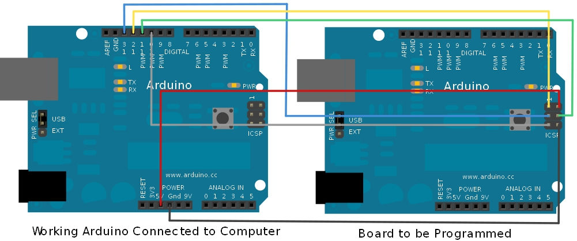

APM 2.6 ISP pins

Keep in mind, that for ISP pins a minimum of three (3) pins are to be used

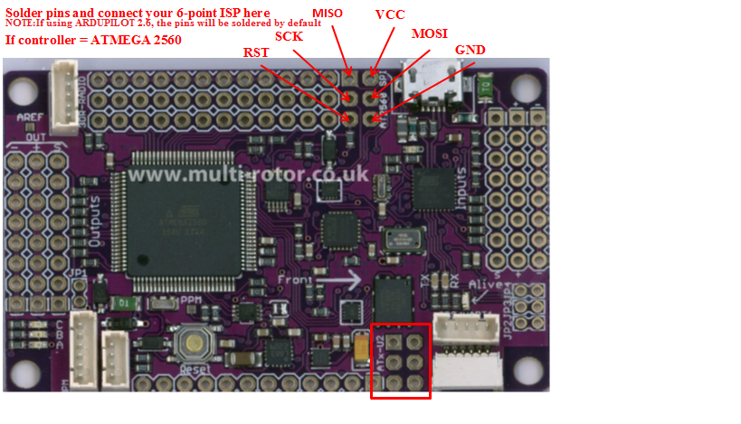

Above are shown the PINS for a sepa- rate ISP if not using ATM to APM. Exc- cluding the ARDUINO UNO

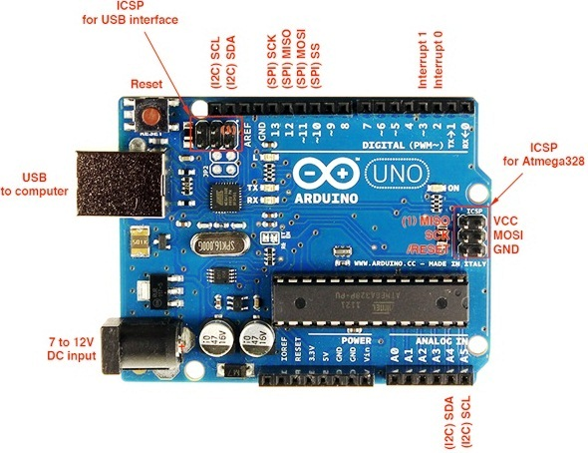

Arduino UNO **is** used as **the bootloader**.

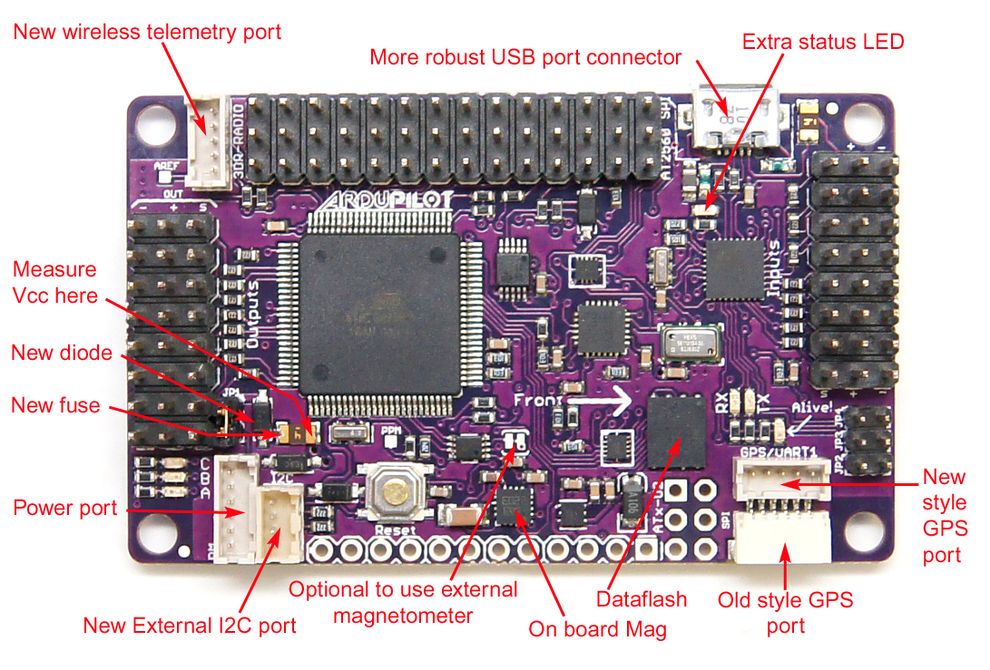

Ardupilot Mega 2.6 is the slave.

This connection uploading is done through the In System Programming headers (ISP).

**Legend:**

|  |  |  |  |
| --- | --- | --- | --- |
| Type | UNO | APM 2.6 | Notes |
| SCK | Pin 13 | See diagram | See Files/Hardware/APMv2.52 |
| MISO | Pin 12/Orange | See Diagram/Orange | See Files/Hardware/APMv2.52 |
| MOSI | Pin 10 | See Diagram | See Files/Hardware/APMv2.52 |
| Vcc | 5V | See Diagram | See Files/Hardware/APMv2.52 |
| GROUND | GND | See Diagram | See Files/Hardware/APMv2.52 |
| RESET | N/A | N/A | N/A |
|  |  |  |  |

N/A – Not need or applicable for current bootloading configuration. Or not available. It does not matter neither it will not be used.